**NCU-FRM-81**

|  |  |  |
| --- | --- | --- |
|  | **COMMUNITY SERVICE TRACKING FORM**  (TO BE SUBMITTED BY THE STUDENT TO THE MENTOR) | **Review Date:** |
| **Sheet 1 of 1** |

|  |  |
| --- | --- |
| NAME & ROLL NO. OF THE STUDENT | Avtar Singh - 20csu241 |
| SEMESTER/ YEAR | VI-FS-B / 3rd Year |
| MEMBERSHIP OF COMMUNITY SERVICE CLUB/SOCIETY AT NCU (Name/s) | Yukti , The Hood, Creater’s Garage,Udaan,Prayaas |
| SIGNATURE AND DATE | Avtar Singh / 28 April 2023 |

**Participation in Club activities at NCU**

|  |  |  |  |  |  |
| --- | --- | --- | --- | --- | --- |
| **S.NO.** | **DESCRIPTION OF ACTIVITY** | **DATE** | **NAME OF CLUB** | **NO. OF HOURS** | **Certificate** |
| **1.** | Caption Writing Event | 11 Aug-15 Aug 2022 | By Udaan | **3 hrs.** |  |
| **2.**  **3.**  **4.**  **5.**  **6.** | Art Therapy Workshop  Jhanda – E – Shaan  Animal Food F eeding Drive  Appreciation For Education  Webinar on Social Well Being | 17th November 2022  11th – 15TH August 2022  11th – 15th August 2022  28th Oct 2022  1st – 2nd Sept 2022 | Manovriti  Aashayeen And Udaan  Prayaas  Prayaas  By Creator’s Garage | **02 hrs.**  **02 hrs.**  **10 hrs.**  **04 hrs.**  **02 hrs.** |  |
|  |  | **TOTAL NO. OF HOURS** | | **23 hrs** |  |

**Participation in activities conducted outside of NCU**

|  |  |  |  |  |  |
| --- | --- | --- | --- | --- | --- |
| S.NO. | DESCRIPTION OF ACTIVITY | DATE | NAME OF NGO/FIRM/SOCIAL INITIATIVE/SELF | NO. OF HOURS | Certificate |
| 1. | A 4-day NGO Visit. | 07 Nov – 10 Nov | Yatan NGO | 40 hrs |  |
|  |  |  |  |  |  |
|  |  | **TOTAL NO. OF HOURS** | | 40 hrs |  |

**Total number of hours: 63 hrs.**

|  |  |  |  |  |  |
| --- | --- | --- | --- | --- | --- |
| **S.NO.** | **DESCRIPTION OF ACTIVITY** | **DATE** | **NAME OF CLUB** | **NO. OF HOURS** | **Certificate** |
| **1.** | Poster Making on Republic Day | 25 Jan 2023 | By ACM | **6 hrs.** | **C:\Users\dell\Downloads\Avtar Singh - Republic Day.png** |
| **2.**  **3.**  **4.**  **5.**  **6.**  **7**  **8** | Engineering Innovation for a More Resillient World  FORCE -DE-FAM  Plant Donation Drive  SAVE THAT DROP  Idea Challenge  Poster Making - Liver  Planet Paws | 2nd Feb 2023  18th – 28TH January 2023  24th April, 2023  20th April 2023  21st April 2023  18th - 19th April 2023  18 April, 2023 to 20 April, 2023 | Chetna And Institution of Engineers(India)  Prayaas  Yukti  Eklevya  By The Awakening Club  By Club Yukti  By  Elevate Club and Prayaas NCU | **12 hrs.**  **27 hrs.**  **5 hrs.**  **11 hrs.**  **08 hrs.**  **10 hrs.**  **4 hrs.** | C:\Users\dell\Downloads\Avtar Singh - World Eng Day.png  C:\Users\dell\Downloads\Avtar Singh - Force De Fem.png  **C:\Users\dell\Downloads\Plant Donation Drive.png**  C:\Users\dell\Downloads\Water.png  **C:\Users\dell\Downloads\Water2.png**  C:\Users\dell\Downloads\Poster Making.png  **C:\Users\dell\Downloads\Planet Paws.png** |
|  |  | **TOTAL NO. OF HOURS** | | **83 hrs** |  |

**Total No. of Hours - 146 hrs**

Annexure

|  |  |
| --- | --- |
| NCU | **The NorthCap University, Gurugram**  **REPORT OF ACTIVITY** |
|  |  |

|  |
| --- |
| 1. **Name of the Activity:** Caption Writing Event |
| **Contribution / Description:** Caption Writing Event was conducted at home on Independence Day  **Number of hours:**03 |
| **Certificate:** |

|  |
| --- |
| 1. **Name of the Activity:** 4 days NGO Visit (Yatan NGO) |
| **Contribution / Description:** I visited yatan NGO and donated grocery, stationary items to the children there. I also conducted some engaging activities like dancing with them, fun quiz contest etc.  **Number of hours:**40 hrs |
| **Certificate:** |
| **Photos / Videos** |

|  |
| --- |
| 1. **Name of the Activity:** Art Therapy Workshop |
| **Contribution / Description: Online Wrokshop**  **Number of hours:2** hrs. |
| **Certificate:** |

|  |
| --- |
| **4.Name of the Activity:** Jhanda – E - Shaan |
| **Contribution / Description: Flag Hosting**  **Number of hours: 2** hrs. |
| **Certificate:** |

|  |
| --- |
| 1. **Name of the Activity:** Animal Feeding Drive |
| **Contribution / Description: Feeding the animals**  **Number of hours: 10** hrs. |
| **Certificate:** |

|  |
| --- |
| 1. **Name of the Activity:** Webinar on Social Wellbeing |
| **Contribution / Description: Webinar**  **Number of hours: 2** hrs. |
| **Certificate:** |

|  |
| --- |
| 1. **Name of the Activity:** Appreciation For Education |
| **Contribution / Description: Make students aware about education**  **Number of hours: 4** hrs. |
| **Certificate:** |

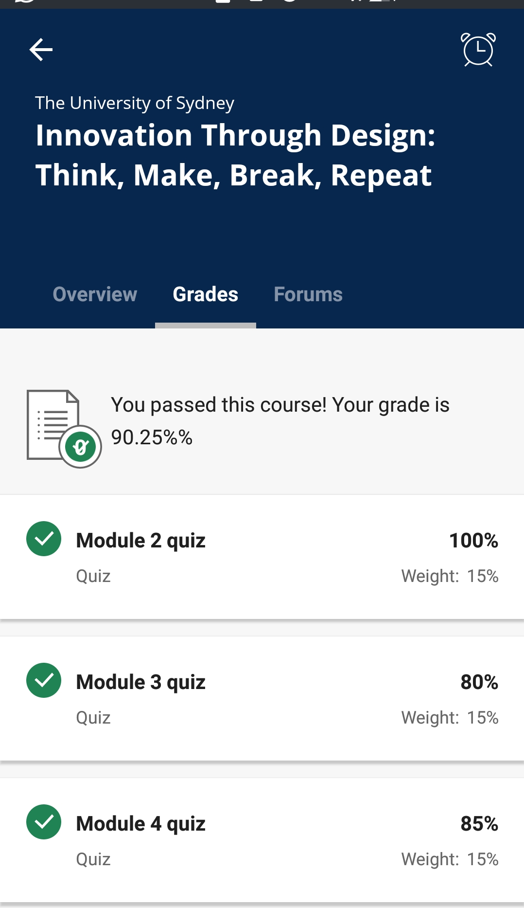

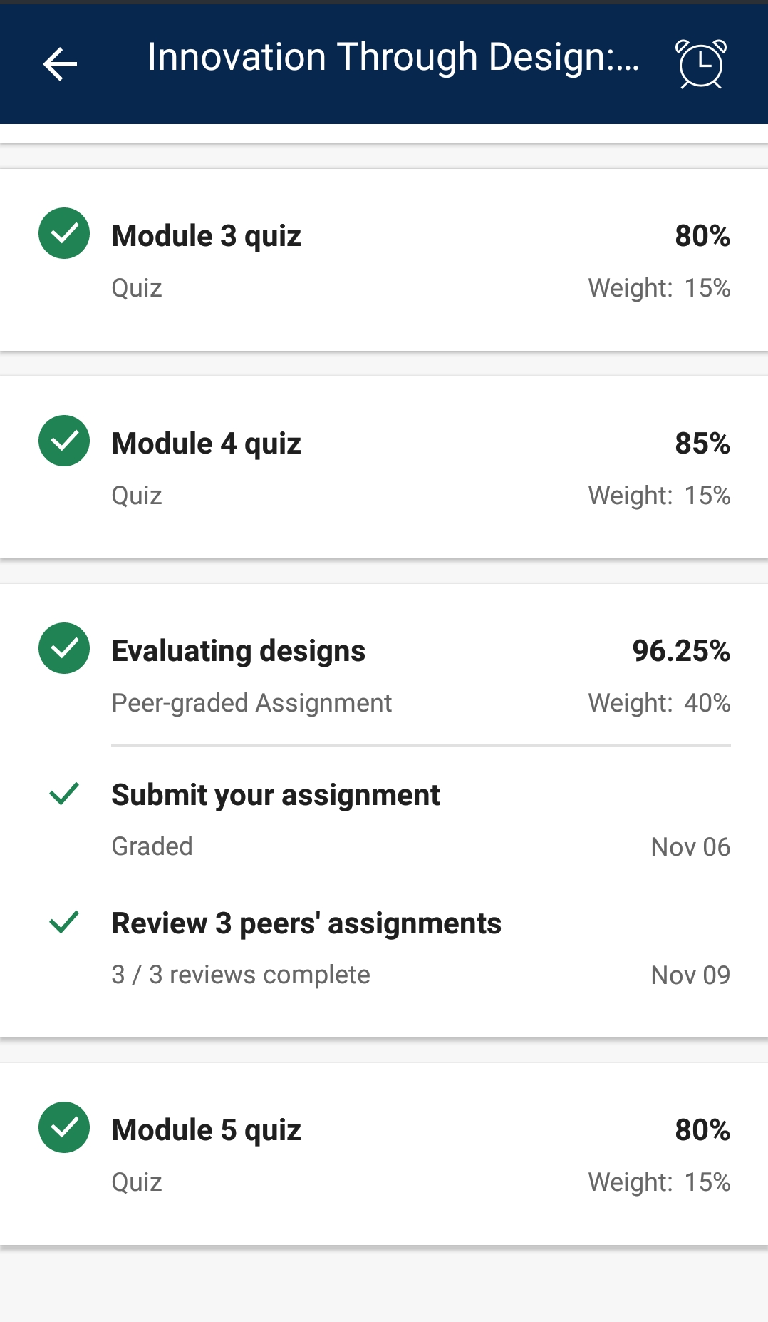

|  |
| --- |
| 1. **Name of the Activity:** Poster Making on Republic Day |
| **Contribution / Description:** Poster Making  **Number of hours:**06 |
| **Certificate:**  C:\Users\dell\Downloads\Avtar Singh - Republic Day.png |

|  |
| --- |
| 1. **Name of the Activity:** Engineering Innovation for a More Resillient World |
| **Contribution / Description:** submitted 5-minute videos on Innovative solutions for Sustainable Development Goals  **Number of hours:**12 hrs |
| **Certificate:**  C:\Users\dell\Downloads\Avtar Singh - World Eng Day.png |

|  |
| --- |
| **3. Name of the Activity:** FORCE -DE-FAM |
| **Contribution / Description: Multiple Activities like Donation , Interaction ,Cleaning**  **Number of hours:27** hrs. |
| **Certificate:**  C:\Users\dell\Downloads\Avtar Singh - Force De Fem.png |

|  |
| --- |
| **4.Name of the Activity:** Plant Donation Drive |
| **Contribution / Description: Donate Plant**  **Number of hours: 5** hrs. |
| **Certificate:**  C:\Users\dell\Downloads\Plant Donation Drive.png |

|  |
| --- |
| **5. Name of the Activity:** SAVE THAT DROP |
| **Contribution / Description: Any water saving activity video , poster**  **Number of hours: 11** hrs. |
| **Certificate:**  C:\Users\dell\Downloads\Water.png |

|  |
| --- |
| **6. Name of the Activity:** Idea Challenge |
| **Contribution / Description: Idea on water Conservation**  **Number of hours: 08** hrs. |
| **Certificate:**  C:\Users\dell\Downloads\Water2.png |

|  |
| --- |
| **7. Name of the Activity:** Poster Making on Liver Health |
| **Contribution / Description: Make students aware about Liver Health**  **Number of hours: 10** hrs. |
| **Certificate:**  C:\Users\dell\Downloads\Poster Making.png |

|  |
| --- |
| **8. Name of the Activity:** Planet Paws |
| **Contribution / Description: Food Donation for Animals**  **Number of hours: 4** hrs. |
| **Certificate:**  C:\Users\dell\Downloads\Planet Paws.png |